Mediashippers Marketplace
Internal Marketplace Operations Documentation
STEP 4 — ASSETS & MARKETPLACE POSITIONING

Reference Workflow Interface
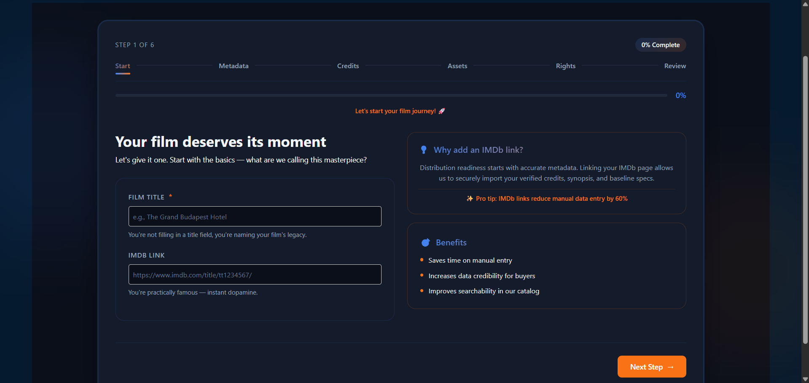
Figure 4.0 — Assets & Marketplace Positioning interface used during content onboarding.

1. Purpose & Core Philosophy
The Assets & Marketplace Positioning workflow represents the commercial presentation layer of the Mediashippers licensing ecosystem. This stage ensures that every uploaded title contains visually marketable assets and business-facing positioning information that improves buyer evaluation, discoverability, recommendation visibility, and licensing attractiveness.
Modern content licensing marketplaces rely heavily on visual presentation quality and commercial metadata when prioritizing submissions. Buyers often review posters, banners, trailers, awards, and positioning details before entering deeper rights or negotiation workflows.

2. Marketplace Objectives
- Improve buyer confidence during title discovery
- Increase recommendation visibility across platform algorithms
- Support commercial evaluation workflows
- Improve content presentation quality
- Enable localization and accessibility readiness
- Provide structured promotional metadata for distribution pipelines

3. Official Promotional Asset Standards
Promotional assets are required to ensure that every title maintains professional marketplace presentation standards. Strong visual assets improve click-through rates, buyer engagement, and recommendation ranking.
Asset Type | Requirement | Purpose | Marketplace Importance
Official Trailer | Optional but Recommended | Provides buyers with a visual preview. | High
Main Poster | Mandatory | Primary artwork across discovery pages. | Critical
Hero Banner | Recommended | Wide-format artwork for platform placement. | High
SRT Subtitle File | Optional | Supports localization and accessibility. | Medium

4. Upload & Validation Standards
Before a title may proceed to publishing review, uploaded assets undergo automated moderation, resolution checks, and metadata validation.
- Poster uploads are mandatory before submission review
- Accepted subtitle formats include .srt and .vtt
- Banner artwork must meet minimum platform resolution standards
- Trailer links may be uploaded directly or provided via external URL
- Corrupted or unsupported files may trigger validation failures
- Asset moderation systems review uploads for quality and compliance
- Missing visual assets may reduce recommendation visibility

5. Marketplace Elements & Commercial Indicators
The Marketplace Elements section captures commercial positioning data used by buyers, acquisition teams, and recommendation systems to evaluate the market potential of a title.
Marketplace Element | Example Entry
Awards Won | 3 National Film Awards, Cannes Selection
Platform Published | Netflix, Prime Video
Box Office Remarks | Estimated $50M+ international potential
Remake Potential | Suitable for international adaptation
TV Rating Potential | Yes
True Story Angle | No
Target Audience | Young Adults (18–35), Sci‑Fi Audience

6. Commercial Evaluation Philosophy
Commercial positioning metadata helps buyers understand how a title may perform across various regional and platform ecosystems. Strong positioning signals often increase buyer engagement and licensing attractiveness.
- Awards and festival selections improve marketplace credibility
- Previously published titles may indicate proven audience performance
- Strong remake potential increases international licensing interest
- Target audience positioning improves recommendation accuracy
- Localization readiness supports global expansion opportunities
- Commercial metadata improves acquisition evaluation workflows

7. Rights & Licensing Standards Integration
All uploaded promotional assets and marketplace positioning metadata remain subject to the Mediashippers Rights & Licensing Standards framework. Usage rights, territory boundaries, exclusivity restrictions, and localization permissions are validated against the platform’s automated Rights Conflict Engine.
- Exclusive rights prevent overlapping distribution within approved territories
- Non-exclusive licensing allows simultaneous distribution across multiple platforms
- Dubbing and localization permissions must be explicitly negotiated
- Geoblocking enforcement is mandatory for excluded territories
- Rights durations exceeding 10 years require administrator approval
- Conflicting asset ownership claims may trigger manual compliance review

8. Dummy Marketplace Asset Submission
The following fictional example demonstrates how promotional and commercial metadata may appear during a professional onboarding workflow.
Field | Dummy Value
Trailer Uploaded | Yes
Poster Uploaded | poster_main_v2.jpg
Hero Banner | banner_cinematic_4k.png
Subtitle File | english_master_subtitles.srt
Awards Won | Toronto Film Festival Nominee
Commercial Positioning | Premium streaming thriller
Target Audience | 18–35 International Streaming Audience

9. Marketplace Discoverability Impact
Visual assets and positioning metadata directly influence how titles appear inside buyer discovery interfaces and recommendation systems. High-quality posters, banners, trailers, and commercial metadata improve engagement across licensing workflows.
- Improves click-through and engagement rates
- Supports AI-powered recommendation ranking
- Increases title visibility during buyer searches
- Enhances professional presentation quality
- Supports global content positioning strategies

10. Workflow Progression
- Start
- Metadata
- Credits
- Assets
- Rights
- Review

11. Internal Training Notes
This onboarding document is intended solely for internal intern training and workflow understanding purposes. All content examples, awards, metadata, commercial indicators, and promotional references used in this document are fictional and created exclusively for simulated marketplace onboarding.
Interns reviewing this workflow should understand how visual presentation, commercial positioning, and metadata completeness influence buyer trust, discoverability, recommendation systems, and licensing attractiveness.
CONFIDENTIAL — MEDIASHIPPERS INTERNAL TRAINING & MARKETPLACE OPERATIONS DOCUMENT

